**Contents**

Project Proposal 2

Goals and Objectives 2

Scope and Deliverables 2

Project Scope 2

In Scope 2

Out of Scope 2

Project Deliverables 2

Project Specification and Target Audience 3

Project Schedule and milestones 3

Resources Required 3

Functional and Non-Functional Requirement 3

Functional Requirements 3

Non-Functional Requirements 4

Project Assumptions 4

Detailed Design 4

Home Page 4

Login Page 4

Admin Book Page 5

Project Testing 8

Testing Scope 8

Testing Enviornment 8

Pass/Fail criteria of the test 8

User Manual 9

Introduction 9

User Activities 9

# Project Proposal

## Goals and Objectives

The main goal of this project is to implement an BookFinalProject Web Application where users can see books. In this application there is a User.User can add books, edit books and delete books. Moreover, user can edit, delete and check details for readers and create, edit, delete and check details for sales records.

## Scope and Deliverables

## Project Scope

This is a 20 days project. Below is the in scope and out of scope items of this project

### In Scope

* Implement user functions like edit, delete user profiles,add, edit, delete books, create,edit, update sales records.
* Test all functionalities.

### Out of Scope

* Any hardware or software cost is out of scope.

## Project Deliverables

To achieve the goal of our project, we have set following deliverables:

|  |  |
| --- | --- |
| **Deliverables** | **Explanation** |
| Planning | This includes the planning and specification of the project. |
| Coding and Implemetation | This will show the coding and implememtation part of the project. |
| Testing and documentation | This will demonstrate how application it will be used and also the test details of the wev app. |
| Final written Report | This will provide the detailed report along with all details of goals, objectives, timeliness etc. |

## Project Specification and Target Audience

Secure login and registration by user.

Add, edit, delete books by user.

Edit, delete of readers by user.

* Create, update, edit and delete the sales records by user.

# Project Schedule and milestones

|  |  |  |
| --- | --- | --- |
| Milestone | Weeks | Deliverable(s) Completed |
| Project planning | 1-2 | * Project Proposal * Project Definition Document |
| Iteration 1 | 2-3 | * Database Design * Front End Design |
| Iteration 2 | 3-4 | * Reader * Seller * Final Product |
| Iteration 3 | 3-4 | * Testing * Final Documentation |

# Resources Required

* Windows OS 10, 4 GB RAM, Minimum i5 processor
* ASP.Net MVC and Identity Framework

# Functional and Non-Functional Requirement

## **Functional Requirements**

* System should allow the user to update the books, readers and sales record.
* System should allow user to delete/update the user information.

## **Non-Functional Requirements**

* System should be secure.
* System should run in any browser
* System should be fast and easy to use.
* System should keep personal details of the users secured.

## **Project Assumptions**

* During the plan I made the following assumption for the application:
* User is available to provide the feedback for system
* Atleast one user has registered at the time of the implementation
* No registration fee

# Detailed Design

## Home Page

This is main page of the web application, which will be common for all users. This page contain home, books,reader signup, login and create shop admin menu options.



## Login Page

Login page allow register user and admin to login into the web app.

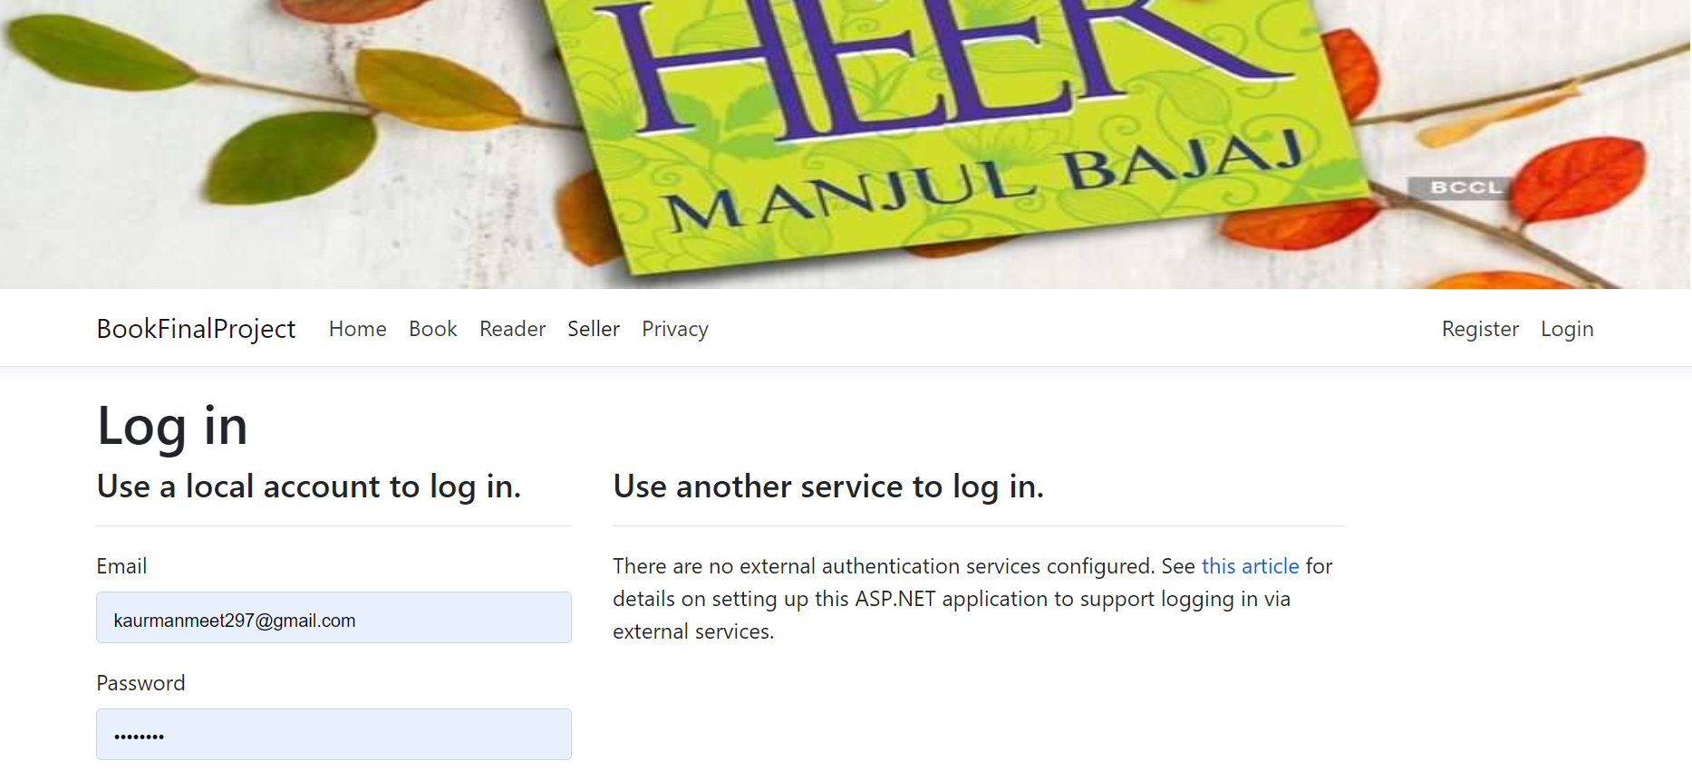

## User Sales Page

In this page admin can create, edit, delete and view details of sales records.

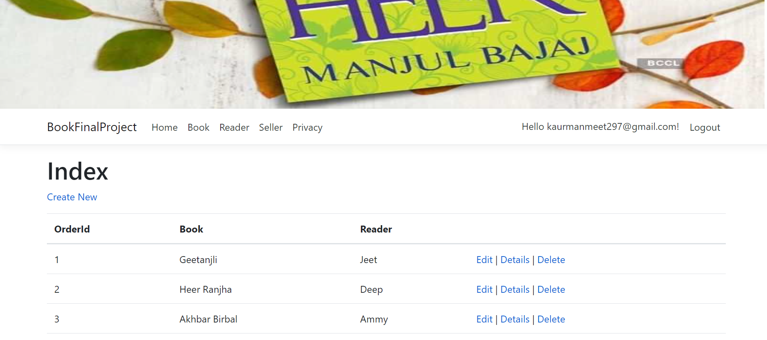

# Project Testing

## Testing Scope

As it has been mentioned before due to limited time period, we prioritized testing of only important parts of the project. In general this report will include:

* Testing of the desktop version
* Testing of the database

Testing process will include, database testing, user interface testing, system and performance testing

Aspects of testing.

* Accessibility
* Compatibility
* Functionality
* Content
* Navigation
* Performance
* Site recognition
* Usability

## Testing Enviornment

All testing will be conducted with using of stand - alone Windows 10 with using Chrome desktop

browser.

* Installed memory (RAM) 8.00 GB. System type: 64-bit Operating System, x64-based processor.
* Windows 10 and Chrome Brower.

## Pass/Fail criteria of the test

Testing process considered to be completed when the main functionality has been tested according to following pass/fail criteria:

* All tests are completed.
* Main functionality is working.
* The percentage of the competed tests are conducted without errors

# User Manual

## Introduction

In BookFinalProject Web Application users can see books.User can add books, edit books and delete books. Moreover, user can edit, delete and check details for readers and create, edit, delete and check details for sales records.

## User Activities

* Registeration
* Login/Logout